|  |
| --- |
| Report of the Head of Planning and Regeneration  To  Portfolio Holder for Regeneration and Growth  On  20 January 2022 |
|  |
| **STATEMENT OF COMMUNITY INVOLVEMENT (SCI)** | |

1. **SUMMARY**
   1. The Statement of Community Involvement (SCI) sets out how and when people are able to get involved with the planning system. It covers both planning policy related consultations (such as the Local Plan) and planning applications, and is a requirement of Section 18 of the Planning and Compulsory Purchase Act 2004.
   2. Planning policy related consultations (including the Local Plan review, supplementary planning documents (SPDs) and any masterplans) need to be carried out in accordance with the SCI.
   3. Local planning authorities must review their SCI’s every five years.
   4. The council currently has a Statement of Community Involvement which was adopted in July 2017, following public consultation.
   5. The revised SCI was considered by the Overview and Scrutiny Committee (Place) on 21 December 2021 following a six week public consultation exercise. It was agreed that the document would to go to the Portfolio Holder for Regeneration and Growth for a delegated decision to adopt the document.

**Key Decision** – The adoption of the SCI is a key decision as the document will impact on all wards within the district. It sets out the way in which the council consults on all planning related matters.

1. **RECOMMENDATION**

2.1 It is recommended that the Statement of Community Involvement (SCI) 2022 (attached at Appendix A) is adopted by the Portfolio Holder for Regeneration and Growth.

1. **BACKGROUND**
   1. The current SCI was published in July 2017 and sets out the Council’s approach to community engagement using a range of methods including consultation events, exhibitions, publicity, social media etc.
   2. On 20 November 2018, a motion was agreed by Council to assess the current methods and channels used when planning applications and wider planning policies are communicated and consulted upon. Overview & Scrutiny Committee (Place) considered the motion on 11 December 2018 and agreed that they were the most appropriate committee to consider potential changes to the planning consultation process.
   3. Various evidence gathering tasks were carried out by officers, as agreed by the committee. This included:
   * giving all councillors an opportunity to email their ideas for better public consultation to officers;
   * holding a useful workshop session, attended by 14 councillors, to discuss current issues with planning consultations and what could be done better;
   * collation of information on what other local planning authorities in Nottinghamshire do;
   * considering any resource implications of the suggestions made by councillors.
   1. However when the country went into lockdown in March 2020 in response to the COVID-19 pandemic, the restrictions put in place to protect public health meant that the requirements of the current SCI could not be complied with.
   2. The Government published an update on planning matters, including temporary measures to make it easier to operate the planning system[1]. Some of the measures include the flexibility to hold virtual planning committees and recognition that consultations would need to be more digital based due to the public health crisis. These measures came to an end on 31 December 2021[2].
   3. Despite this, some of the current SCI requirements were inconsistent with the guidance on staying at home and away from others, for example, holding face-to-face community consultation events or providing physical documents for inspection.
   4. Although the country is currently out of lockdown and the vaccination and booster programme continues to be rolled out, it is important that the SCI is revised to allow for consultations to continue should there be another COVID-19 wave, or any other circumstances where face to face contact is restricted.
   5. In addition to this, the current SCI is due to be reviewed / revised by 2022.
   6. To be legally compliant, planning policy documents must be consulted on in accordance with the SCI. A revised SCI (attached as Appendix A) has been finalised following a six week consultation period. Upon adoption this would allow plan-making to progress should further restrictions occur. This revised document takes account of suggestions previously made by elected members, and by members of the public during the consultation period.

**4. OPTIONS AVAILABLE**

4.1 The council is required by planning legislation to have a SCI. Whilst there are a number of possible alternative ways that the revised document could be set out, this approach is considered to be a good compromise between detail, length and readability.

**5. RISK ASSESSMENT OF RECOMMENDATIONS AND OPTIONS**

5.1 It is recommended that the Statement of Community Involvement (SCI) 2022 (attached at Appendix A) is adopted by the Portfolio Holder for Regeneration and Growth.

|  |  |  |  |
| --- | --- | --- | --- |
| **Risk** | **Risk Assessment** | **Risk Level** | **Risk Management** |
| Reputation | Adopting the 2022 SCI avoids the risk of future criticism that the SCI is not up to date and current | Low. | Having an up to date SCI means that consultations can continue to be carried out should the government call for further restrictions due to Covid-19. It also means that we have met the requirement to update our 2017 SCI. (This needs to be done every five years). |
| Legal | May face legal challenges in the future related to the Local Plan if consultation has not been carried out in accordance with the SCI. | Low | The 2022 SCI would prevent any legal challenge from being successful as it allows for consultations to continue. |

**6. ALIGNMENT TO COUNCIL PRIORITIES**

6.1 Production of a local plan and associated planning documents are specific actions that need to be undertaken to meet corporate priorities. The Statement of Community Involvement is central to this, as well as the council’s general commitment to supporting community engagement.

**7. IMPLICATIONS**

7.1 It is important to note that no decision on this report will change normal council policy. The adoption of this document simply reinforces our commitment to continue to provide opportunities for good community involvement in planning decisions. The only change to policy would occur if there are further periods of restrictions which may impact upon face to face contact. In this scenario, the 2022 SCI allows the council to continue consultations, albeit with more emphasis on digital methods of engagement.

(a) Relevant Legislation – It is a requirement of the Planning and Compulsory Purchase Act 2004 (as amended by the Localism Act 2011) for the council to produce a Statement of Community Involvement (SCI).

(b) Human Rights - No impact as there are no major changes to policy as a result of this report.

(c) Equality and Diversity - There are no direct implications of producing the SCI. However, the content of the document provides procedures to ensure that planning related consultations undertaken will be accessible to all members of the community.

(d) Climate change and environmental sustainability- No impact as there are no major changes to policy as a result of this report.

(e) Crime and Disorder- No impact as there are no major changes to policy as a result of this report.

(f) Budget /Resource- No impact as there are no major changes to policy as a result of this report.

**8. COMMENTS OF STATUTORY OFFICERS**

(a) Head of Paid Service – N/A

(b) Monitoring Officer – Requested information added to report regarding equality impact. This was added at paragraph 7.1(c) above.

(c) Section 151 Officer – No specific comments.

**9. CONSULTATION**

* 1. A six week public consultation was carried out on the draft SCI.
  2. Notifications which explained the purpose of the consultation and invited representations to be made were sent, either electronically or by post, to 2,687 individuals and organisations registered on the local plan database. The document was also made available on our website, at the Civic Centre and all county libraries in the district. A press release was issued, as well as a series of social media posts, and four drop in session were also held across the district.
  3. 17 representations were received and all comments are summarised (along with a response) in the attached consultation statement (Appendix B). Some of the key issues that were raised are as follows:
* use of terms such as ‘may’ rather than ‘will’ makes the document unclear and too discretionary;
* verbal comments should be considered;
* concerns over the definition of ‘valid’ comments and who decides this;
* concerns over the amount of site notices to be erected;
* more significant changes were made than reported to OSC Place and the Portfolio Holder for Regeneration and Growth;
* the February 2021 version didn’t include suggestions made by elected members;
* comments received should be published on the council’s website;
* all households should be notified of local plan / planning document consultations by post;
* concerns over the need to publish people’s names alongside their comments; and
* concerns over the accuracy of comment summaries.
  1. All these issues have been addressed in the consultation statement (Appendix B).
  2. The main changes that have been made to the document as a result of the consultation (and the pre-consultation engagement with elected members) are listed below. The document now:
* sets out that officers will be reasonable and respectful towards members of the community (paragraph 1.13);
* includes changes to Table 1 to clarify some of the examples of what are not material planning considerations (valid comments);
* includes an appendix which has replaced text from paragraph 1.15, old 1.16 and throughout the document to contain all changes that will be made to the consultation processes in extraordinary circumstances, such as a pandemic, rather than having the information within the main document (Appendix B);
* makes it clearer that planning applications (via the PC terminals in the reception area) and planning policy documents can be viewed at the Civic Centre by appointment (new paragraphs 1.16 and 3.20);
* includes an amended web address for the Planning Portal in new paragraph 1.23;
* includes a key to Table 4 to make it clearer;
* includes distribution of information to community groups, shops etc. to Table 5;
* includes signing people up to our local plan consultation portal at consultation events to Table 5;
* includes amendments to Table 5 to split statutory consultees and other target groups in order to make this distinction clearer;
* includes amendments to all references to ‘neighbourhood councils’ to ‘neighbourhood forums’ (Table 7);
* includes additional text in the ‘pre-application stage’ section of the SCI to encourage early engagement with statutory consultees (new paragraphs 3.6 and 3.9);
* includes an additional appendix to signpost applicants to standing advice from statutory consultees (Appendix D);
* includes additional text at paragraph 3.12 regarding use of more eye catching site notices, with QR codes;
* includes additional paragraph 3.14 regarding contacting councillors;
* includes additional paragraph 3.15 regarding use of social media to advertise planning applications and,
* includes a summary of enforcement and contact details at new paragraph 3.37 onwards.

Officers have also:

* passed feedback on the website onto relevant team at MDC;
* set up a weekly Facebook and Twitter post to advertise the weekly list of planning applications;
* trialled more eye catching site notices;
* added QR codes to our site notices and posters;
* arranged for a message to be displayed on the digital screen in the Civic Centre to promote viewing planning applications online;
* explored other methods to increase awareness of the Local Plan;
* contacted all of the district’s county councillors following their election in May 2021 to advise them that they can sign up to receive the weekly list and,
* made other minor amendments / clarifications to the document.

And will:

* continue advertising the local plan consultation portal within each publication of My Mansfield;
* encourage consultees to check / update their details on the next consultation notification letter / email that is sent;
* ensure people are greeted at future drop in sessions where possible;
* consider providing signage at consultation events to indicate that comments must be made in writing;
* use site notices at all relevant Regulation 18 consultations;
* include local site names (also known as….) when describing land in consultation material;
* continue to meet with relevant ward councillors regarding any new allocations and provide them with information leaflets / notices; and
* continue to use the council’s Facebook page and Twitter feed when consultations are due to take place (this gives access to approximately 15,600 Facebook followers and 6,800 Twitter followers).
  1. The main changes to the SCI (when compared to the 2017 version) are that it now includes what will happen during extreme circumstances such as during the COVID-19 pandemic. This information is found in an appendix to the SCI. It includes a heavier reliance on digital (online) consultation methods (than in normal circumstances) whilst still taking reasonable steps to ensure sections of the community that don’t have internet access are involved.
  2. The document has also been updated to refer to the ‘adopted’ Mansfield Local Plan, and how communities can get involved in its review.
  3. Other changes made to the document were to simplify the text, correct errors and ensure that any misleading text was removed / replaced.
  4. The evidence gathering work undertaken by officers highlighted that our consultation processes are broadly similar to those undertaken by the other local planning authorities in Nottinghamshire (see Appendix C). Whilst this is not a reason to keep MDC’s processes the same, this exercise has made it clear that most LPAs are not going over and above the legal requirements (especially in relation to planning applications). In the context of local authority budget pressures this is not surprising.
  5. Some ideas raised by members have been included in the revised SCI, or are being investigated further. This includes:
* site notices to be printed on coloured paper to make them more noticeable and the addition of QR codes;
* publication of planning application information on social media;
* production of a video to explain how to comment on applications via our website (Public Access);
* use of public noticeboards in town centres;
* addition of relevant county councillors to weekly list circulation list; and
* signing people up for local plan updates at consultation events.
  1. Not all of the suggested improvements have been incorporated into the document due to them not always being practicable or cost effective. The consultation statement gives details of this.
  2. A Public Access user guide was prepared for members in 2017 when the software was purchased and is attached at Appendix D for information.

1. **NEXT STEPS**
   1. When adopted the SCI will be followed when the council consult on planning policy documents, and planning applications.

**11. BACKGROUND PAPERS**

None.

|  |  |  |
| --- | --- | --- |
| Report Author | - | Tracey Tucker |
| Designation | - | Senior Planning Policy Officer |
| E-mail | - | [ttucker@mansfield.gov.uk](mailto:ttucker@mansfield.gov.uk) |

Appendix A - Statement of Community Involvement 2022 (January 2022)

Appendix B - Statement of Community Involvement – Consultation Statement

Appendix C – Summary of consultations carried out by Nottinghamshire local planning authorities

Appendix D – Public Access User Guide

The Statement of Community Involvement 2017 can be viewed at: [www.mansfield.gov.uk/planningconsultation](http://www.mansfield.gov.uk/planningconsultation) (scroll to the bottom of the web page).

**APPENDIX A – Statement of Community Involvement 2022 (January 2022)**

*Document to be attached*

**APPENDIX B – Statement of Community Involvement – Consultation Statement**

*Document to be attached*

**APPENDIX C – Summary of consultations carried out by Nottinghamshire local planning authorities (2019)**

|  |  |  |
| --- | --- | --- |
| **Local Planning Authority** | **Type of consultation** | **Methods used** |
| Ashfield | Planning applications | Meets legal requirements, and exceeds by:   * publicising Green Belt applications in the local newspaper. |
| Development Plan Documents (i.e. Local Plans) | How?   * make consultation documents available at the Council Offices and all four major libraries; * make full use of the media including the Council’s web site, community publications (where practical), local newspaper adverts and press releases; * utilise social media and Quick Release (QR) Codes if available and appropriate; * send letters / emails to all parties registered on the Local Plan Consultation Database; * place information stands/displays at Council Offices and the four major libraries (subject to consent from the libraries); * undertake presentations and questions and answer sessions to Parish Councils and Neighbourhood Forums; * circulate posters across the District to publicly accessible buildings, such as community centres, post offices and shopping centres (where consent is given from the relevant parties); and * disseminate information regarding the Local Plan and any consultation to various sections of the Council to ensure joint working.   When?   * Draft Local Plan – six weeks minimum * Publication Local Plan – six weeks |
| Supplementary Planning Documents | How?   * make consultation documents available at the Council Offices and all four major libraries; * make full use of the media including the Council’s website, local newspaper adverts and press releases; * utilise social media if available and appropriate; * disseminate information regarding the Local Plan and any consultation to various sections of the Council to ensure joint working.   When?   * Draft SPD – four weeks minimum * Adoption statement sent to anyone who has asked to be kept informed |
| Neighbourhood Plans | How?   * Make documents available on council’s website; * Make documents available in the nearest local council office or library or other suitable location; * Place information in the local parish council newsletter; * Notify the relevant consultation bodies as set out in the regulations; and • Use social media and local media/ press. * In the case of a Community Right to Build Order, notify by letter those whose property abuts the area covered by the proposed order.   When?   * The designation of a Neighbourhood Area for the purposes of producing a Neighbourhood Plan * The approval of a specific group who will prepare a Neighbourhood Plan for a specific area * support consultation on a Pre-Submission Neighbourhood Plan * Publicise the submission of the document to the council ahead of submission for independent examination * Publication of the examiner’s report * Decision on whether to “Make” (accept) or refuse a plan * Publicising the decision to “Make” the Neighbourhood Plan |
| Bassetlaw* | Planning applications | Meets legal requirements |
| Development Plan Documents (i.e. Local Plans) | How? (may include, but not limited to, the methods below)   * Digital services: The Council’s website will be key for publicising consultation events to all users, while outgoing emails can carry publicity information, directing and enabling users/recipients to respond to the consultation through embedded surveys; * Registered contacts on council’s database notified of what documents are under consultation, how they can access them and comment on proposals; * Making publications accessible: Consultation documents will be available to view on the Council’s website, while paper copies will also be made available in district council offices and county council libraries; * Print media: Local press releases (both printed media and radio) will be issued to publicise new documents and consultation events, including Parish Council newsletters; * Social media: Primarily using the Council’s email alert service, along with Twitter and Facebook accounts we will publicise the consultation process and events, with links to the website and other publications. Through Twitter and Facebook we can also ask related organisations/publications to post consultation details on their profiles in order to reach a wider audience; * Line of sight publicity: Posters and displays located in prominent positions within all Council offices, around town centres and in other locations/ facilities with help from the Community Partnership; * Events: Public meetings, exhibitions, market stalls, drop-in sessions and staff/member briefings give opportunities to present information and discuss matters of concern. Where appropriate, planning consultation may ‘piggy-back’ on other events being run by the Council or partner organisations; and * Meeting special needs: Where particular special needs are not being met through the above means of engagement, the Council will, where possible respond on request in order to facilitate individuals’ involvement in consultation.   When?   * Scoping report – six weeks * Publication Draft Local Plan – six weeks * Notification to all consultees about the intention to adopt the Local Plan |
| Supplementary Planning Documents | How?  As above.  When?   * Draft SPD – four weeks minimum |
| Neighbourhood Plans | How?   * publicise the progression of neighbourhood plan development on the council’s website, including designations, consultations, and referendums, supported by key documents and decision notices. * Other mediums of communication will also be used as considered appropriate to bring the plan preparation process to the attention of those who live and work in the Designated Neighbourhood Area.   When?   * Designation of a neighbourhood area – six weeks if required * Submission to Local Planning Authority – six weeks |
| Broxtowe | Planning applications | Meets legal requirements |
| Development Plan Documents (i.e. Local Plans) | How?   * Adverts in all local newspapers; * Making consultation documents available at Deposit Points, libraries, council planning office, customer services and the council’s website; * Notification by letter / email to consultees / stakeholders; * Internal consultation with other council departments and services; * Notices within Reception, Customer Service and Deposit Points; * Article in ‘Broxtowe Matters’ if possible; * Potential use of "Planning for Real" exercise; * Possible use of Roadshow, Public Meetings; or area/site based exhibitions or other events and activities set up purposefully to gather views of the 'hard-to-reach' and other residents; * For site specific issues and allocations use of notices to be placed on site(s); * Area based/site based exhibitions; * Potential for awareness raising through use of media (TV/Radio etc); * Use of web * Topic-based workshops; * Site-specific workshops; and * Social media.   When?   * Scoping report * Issues and Options – six weeks * Preferred Options – six weeks * Pre submission – six weeks |
| Supplementary Planning Documents | No information available |
| Neighbourhood Plans | No information available |
| City | Planning applications | Meets legal requirements |
| Development Plan Documents (i.e. Local Plans) | How?   * Written / email notification to statutory and general consultees on our database, other relevant stakeholders, individuals and organisations who have expressed a wish to be consulted or have made comments on previous stages; * Make consultation documents available on the Council’s website and in hard copy format at Council offices and the central library. Key documents will also be available at all Public libraries; * Publicise on the Council’s website; * Where development proposals relate to a specific area of land, post notices in prominent locations in the area; * Public consultation event(s) with such events held in accessible locations; * Publicise using Council publications, where timescales permit; * Social media. * Information on the council’s website (planning webpage) and its engagement / consultation webpage.   When?   * Pre-production informal Consultation * Preferred option (optional stage) – six weeks * Pre submission document – six weeks |
| Supplementary Planning Documents | How?   * Written / email notification to statutory and general consultees on our database, other relevant stakeholders, individuals and organisations who have expressed a wish to be consulted or have made comments on previous stages; * Make consultation documents available on the Council’s website and in hard copy format at Council offices and the central library. Key documents will also be available at all Public libraries; * Publicise on the Council’s website and press adverts; * Where development proposals relate to a specific area of land, post notices in prominent locations in the area; * Public consultation event(s) with such events held in accessible locations; * Publicise using Council publications; * Social media. * Information on the council’s website (planning webpage) and its engagement / consultation webpage.   When?   * Draft SPD |
| Neighbourhood Plans | How?   * Written / email notification to statutory and general consultees on our database, other relevant stakeholders, individuals and organisations who have expressed a wish to be consulted or have made comments; * Make consultation documents available on the Council’s website and in hard copy format at Council offices and public libraries; * Publicise with press adverts and council publications; * Public consultation event(s) with such events held in accessible locations; * Social media. * Information on the council’s website (neighbourhood planning webpage).   When?   * The designation of a Neighbourhood Area for the purposes of producing a Neighbourhood Plan * The approval of a specific group who will prepare a Neighbourhood Plan for a specific area * Consultation on a draft Neighbourhood Plan prior to submitting the document for independent examination * Publication of the examiner’s report * Decision on whether to “Make” (accept) or refuse a plan * Publicising the decision to “Make” the Neighbourhood Plan |
| Gedling | Planning applications | Meets legal requirements |
| Development Plan Documents (i.e. Local Plans) | How?   * prepare a consultation strategy; * contact statutory consultees and organisations and individuals * registered on the Planning Policy database direct; * publicise consultations by methods such as leaflets, websites, posters, displays, commercial, community and social media, social network sites, existing community groups, community events and joining * with other consultations; * write to properties in the immediate vicinity of allocated sites and put up site notices around the site; * leave consultation documents on display at certain locations open to the public like Council offices and libraries; * make consultation documents available on Gedling Borough’s website; * consider organising events such as stakeholder meetings or workshops; and * publish comments received and/or provide a summary as soon as possible, and; * explain how these comments have been considered when decisions are taken.   When?   * Scoping report; * Issues and options; * Preferred options (if necessary); and * Proposed Submission - six weeks. |
| Supplementary Planning Documents | How?   * contact appropriate organisations and individuals direct; * publicise consultations by methods such as leaflets, websites, posters, displays, commercial, community and social media, social network sites, existing community groups, community events and joining with other consultations; * leave consultation documents on display at certain locations open to the public like Council offices and libraries; * make consultation documents available on Gedling Borough’s website ; * consider organising events such as stakeholder meetings or workshops; and * publish comments received and/or provide a summary as soon as * possible, and; * explain how these comments have been considered when decisions are taken.   When?   * Scoping report; * Informal consultation; * Draft Planning Document - at least four weeks; and * Inform those who have commented when SPD is adopted. |
| Neighbourhood Plans | How?   * Publishing the Submission Regulation 16 Neighbourhood Plan for a   minimum of six weeks and inviting representations  When?   * Submission – six weeks |
| Mansfield | Planning applications | Meets legal requirements and exceeds by often erecting site notices as well as writing to residents of adjoining properties |
| Development Plan Documents (i.e. Local Plans) | How?   * Make documents available on council's website, council offices, and local libraries; * Target specific groups such as the parish council, business organisations, developers/landowners/agents; * Hold events in accessible locations and at appropriate times * Promote all events via social media, council’s website and press releases; * Direct emails / letters to all individuals / organisations on local plan database; * Social media; * Publication of information in council magazine ‘My Mansfield’; * Press releases; * Leaflets / postcards / posters at the Council Offices, libraries, leisure centres and health centres as well as a range of venues frequented by people such as supermarkets; * Walk in informal events / exhibitions; and * Static (unattended) exhibitions.   When?   * Scoping report / draft versions / preferred options * Publication Draft – six weeks |
| Supplementary Planning Documents | How?   * No information available in current SCI   When?   * Scoping report * Draft SPD * Adoption statement sent to any person who has asked to be notified |
| Neighbourhood Plans | How?   * No specific information on the methods of consultation in current SCI   When?   * No specific information on the stages of consultation in the current SCI |
| Newark and Sherwood | Planning applications | Meets legal requirements, and exceeds by:   * often erecting site notices as well as writing to residents of adjoining properties and; * displaying a site notice and publishing a newspaper advert for developments affecting a conservation area or its setting. |
| Development Plan Documents (i.e. Local Plans) | How?   * Contact appropriate people / organisations by letter / email; * Publicise the consultation via appropriate local media and if possible in the Council’s Voice magazine; * Social media; * Make consultation documents available in libraries, the council offices and council website; * Consider organising exhibitions, briefing sessions, workshops or meetings.   When?   * Issues and Options – six weeks * Preferred Approach Report – six weeks * Publication Local Plan – six weeks |
| Supplementary Planning Documents | How?   * As above   When?   * Draft SPD – six weeks |
| Neighbourhood Plans | How?   * Publishing neighbourhood forum / neighbourhood area applications for consultation; * Publishing draft neighbourhood plans for consultation; * Making (adopting) plans that achieve majority support at a referendum and publishing them on the Council’s website.   When?   * As appropriate |
| Rushcliffe | Planning applications | Meets legal requirements and exceeds by:   * Additional publicity and/or neighbour notification will generally be undertaken depending on the scale of the development. |
| Development Plan Documents (i.e. Local Plans) | How?   * Contact appropriate organisations / individuals directly; * Publicise consultations using leaflets, posters, websites, press releases, displays, working with existing community groups, attending community events and joint consultations; * Make consultation documents available at locations open to the public (Rushcliffe Community Contact Centre, libraries); * If requested, and applying reasonable charges, make documents available to community groups, councils and statutory organisations; * Consider organising events such as stakeholder meetings / workshops; * Publish comments / provide summaries as soon as possible; and * Explain how comments have been considered when decisions are taken.   When?   * Scoping report; * Issues and options; * Preferred options (if necessary); and * Proposed Submission - six weeks. |
| Supplementary Planning Documents | How?   * As above   When?   * Scoping report; * Draft Planning Document * Consider the need for further consultation before adoption. |
| Neighbourhood Plans | How?   * Publicise the application and designation of neighbourhood forums / neighbourhood areas * Undertake consultation at Reg 16 – publicise details of the plan including where and when the neighbourhood plan can be inspected on the Council’s website. Also provide details of how representations to the plan can be made, how requests to be notified of the decision on the plan can be made, and the date by which those representations should be received. * Publish the examiner’s decision statement and send a copy to the relevant Parish Council and any person who asked to be notified of the decision. * Publish the neighbourhood development plan/order stating where and when it may be viewed and notify any person who asked to be notified of the making of the neighbourhood development plan/order   When?   * Application stage - six weeks * Pre submission stage – six weeks * Publication of examiner’s report * Notification of a ‘made’ neighbourhood plan |

*Information correct at time of writing this appendix - taken from draft version of the council’s SCI, currently or recently out for consultation.

**APPENDIX D – Public Access User Guide**

Welcome to Public Access – Mansfield District Council’s online planning database.

This database can be used to view valid current and decided planning applications, including any plans and documents submitted with the application and subsequent decision notices and officer reports.

You can also register your email and set up searches for areas of interest.

Public Access can be found using the following link

<https://planning.mansfield.gov.uk/online-applications/> You can then set up a shortcut from your pc or ipad desktop to access the database directly.



**To view an application**

From the link the database will open on the screen below Planning - Simple Search

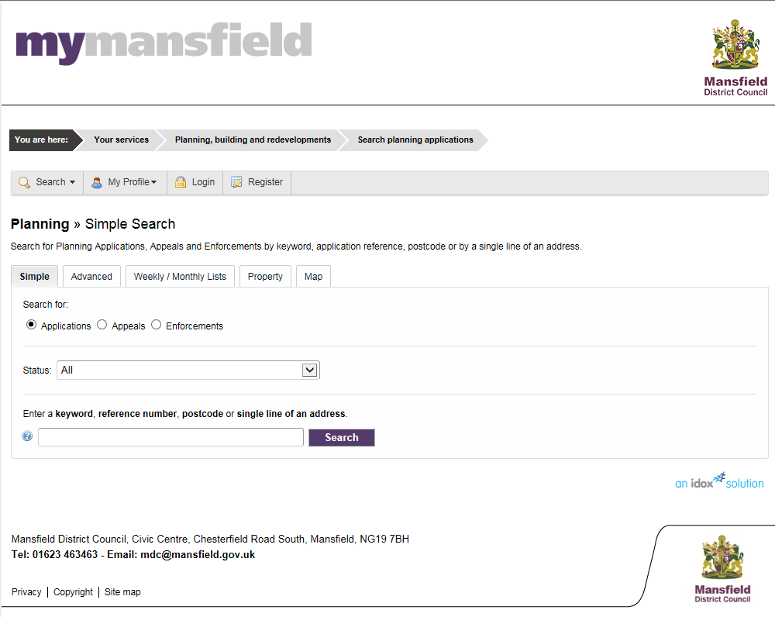

Type in the reference number of the application you are wishing to view and click search

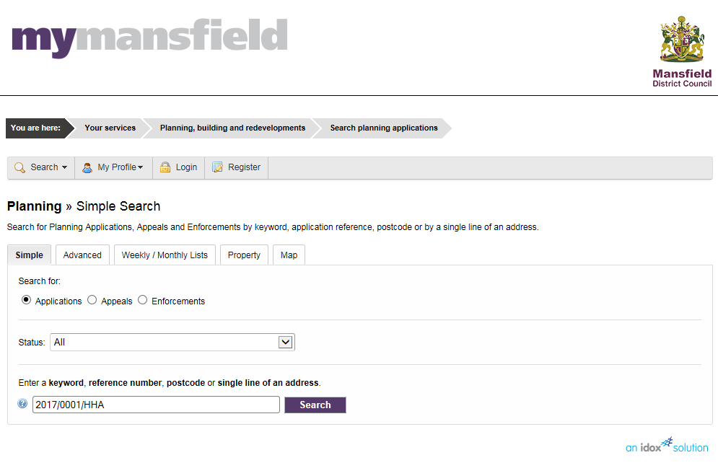

This will then open up the summary details for the application

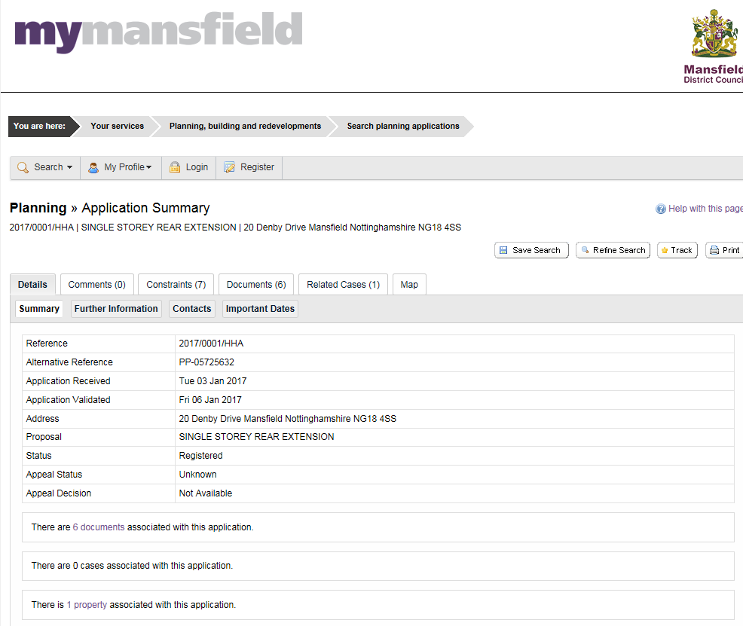

From here you can click on the Documents Tab to view the forms, plans and supporting information submitted with the application

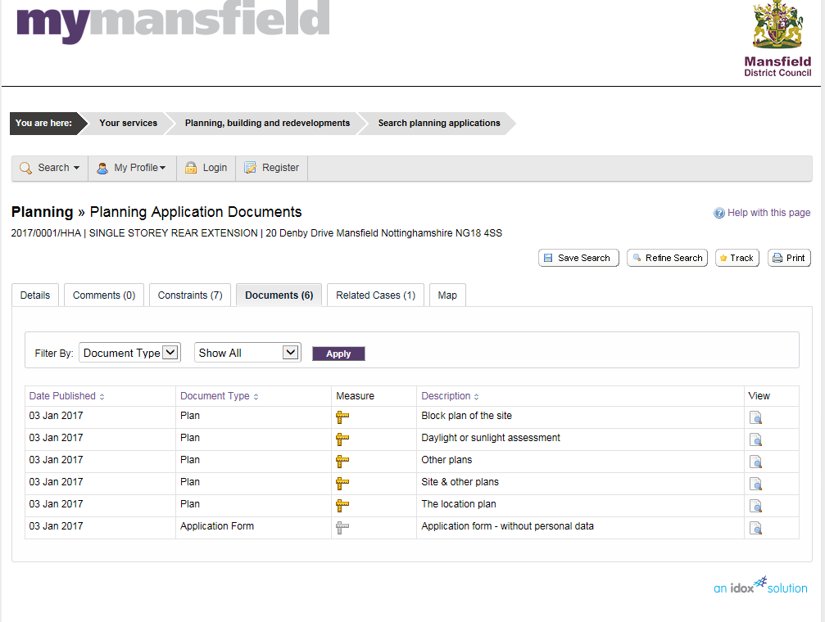

A list of all documents received will appear and you can click on View to see them individually.



To close one document and go to the next click on the cross in the top right hand corner of the screen. The following message will appear

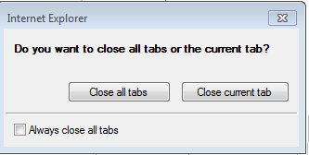Click on Close current Tab and you will return to the list of documents.

You can also view any Consultee comments that may have been received by the Planning Department by clicking on the comments tab

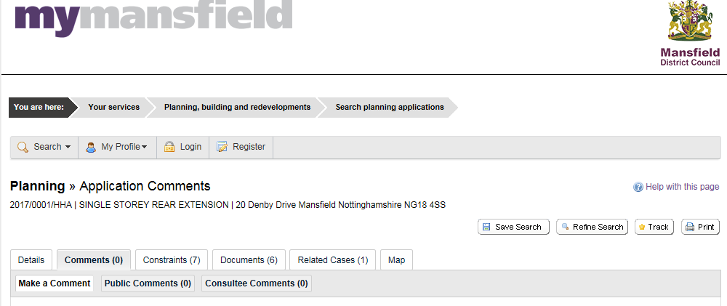

You will then see a list of Consultee comments received, these can then be viewed in the same way as plans and document.

Please note: Neighbour comments are not made public on the website.

To close down the application click on the cross in the top right hand corner of the screen.

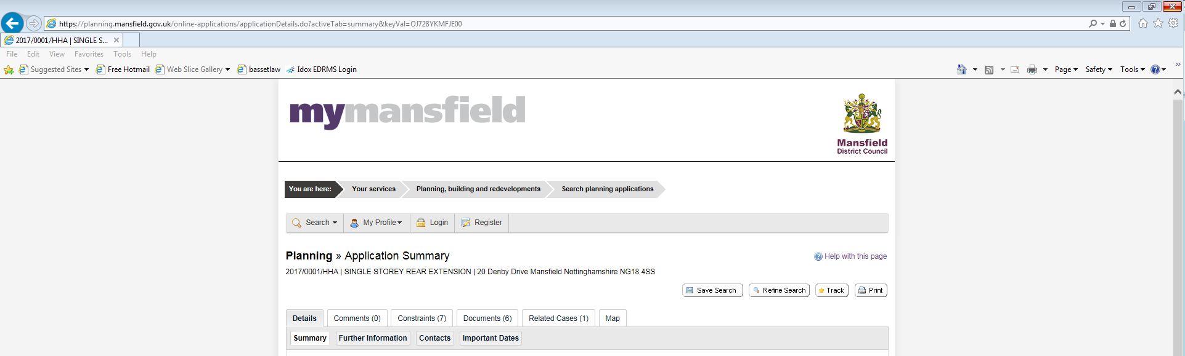

**To Register**

Click on register from the home screen and enter your details and create a password.

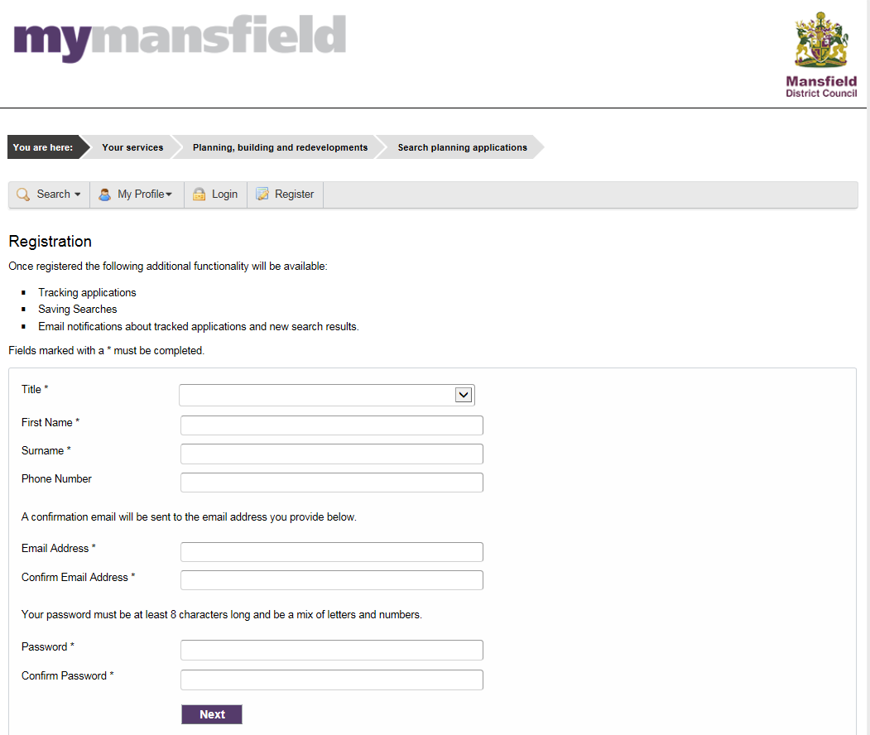

You will be sent a confirmation email with a link to verify your email. Once you are registered you can login to create a search and/or track an application

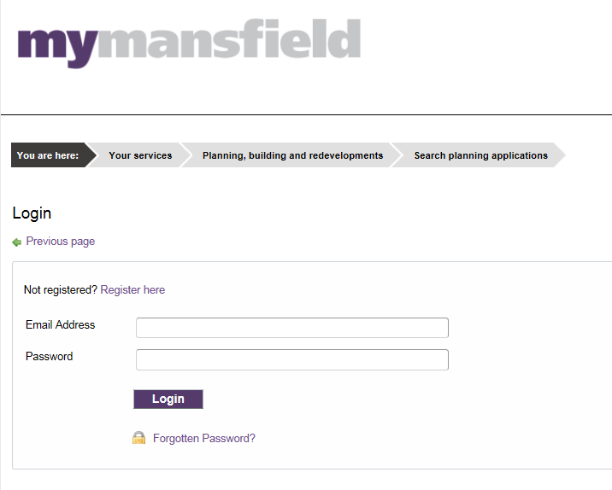

**To save a search**

Perform a search using your chosen criteria, e.g. all 2017 on Leeming Lane North.

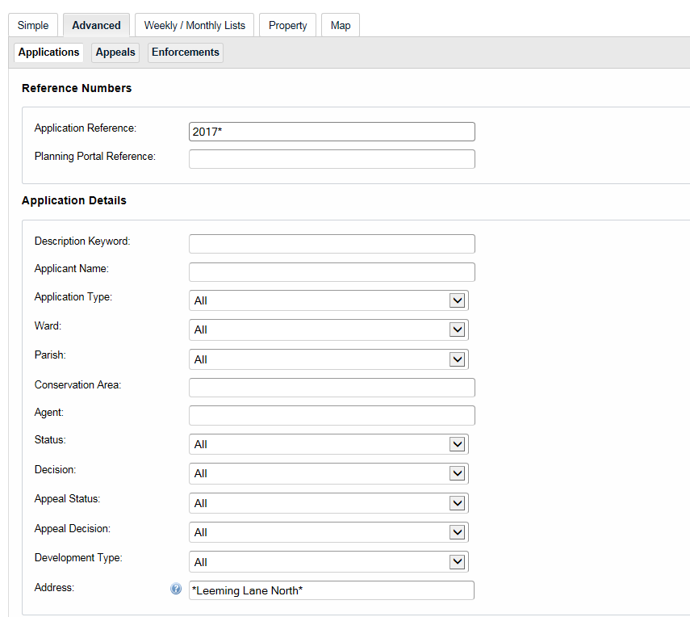

When your search results appear you can click on saved search

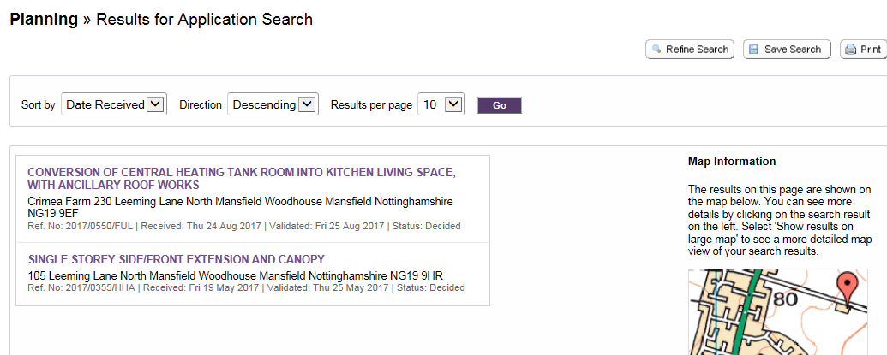

Your chosen searches will then appear in the Saved Searches tab

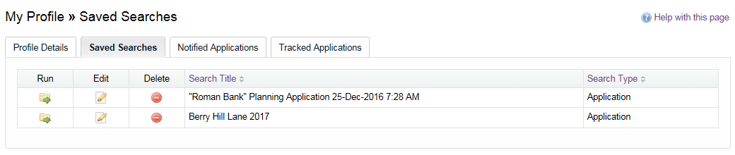

If you have chosen to receive notifications when a new application appears on the search you will receive an email with a link to view the new application.

1. <https://www.gov.uk/guidance/coronavirus-covid-19-planning-update>
2. In accordance with the Town and Country Planning (Local Planning, Development Management Procedure, Listed Buildings etc) (England) (Coronavirus) (Amendment) Regulations 2020 (24 December 2020).